Call For Entries

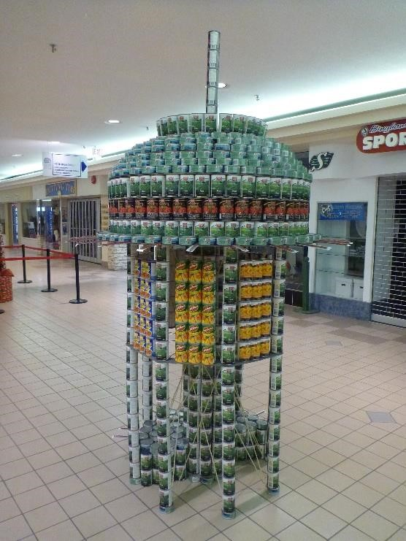
THE 13TH ANNUAL DESIGN
AND BUILD COMPETITION
TO BENEFIT THE FOOD BANKS OF
LETHBRIDGE

WHO
Teams of Lethbridge Architects, Engineers, Contractors, Designers, and students attending Schools of Architecture, Engineering and Design.

WHAT
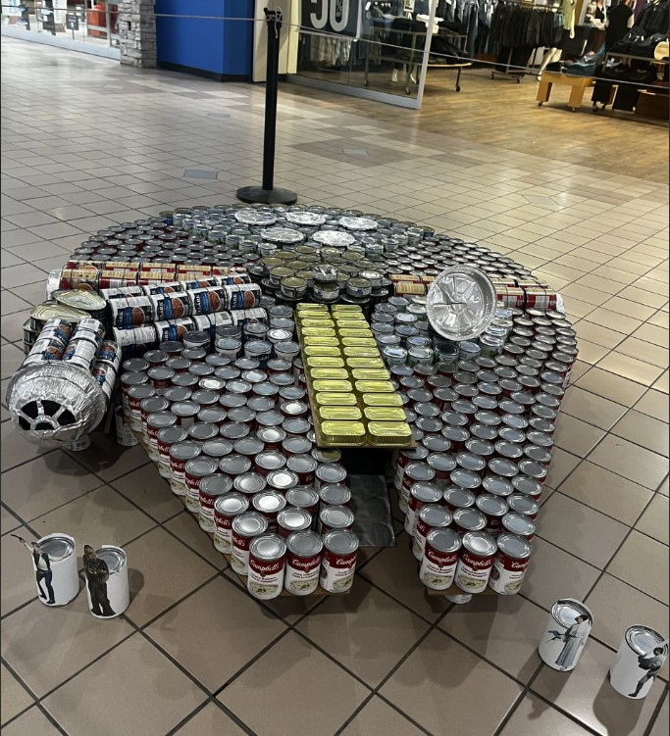
Design and build structures made entirely from canned foods within a 10’x10’x10’ space.

WHEN
Deadline for Entry December 19, 2025
Order Date for Cans February 5, 2026
Team Write Up Submission February 23, 2026
Build Day March 5, 2026
Awards Luncheon March 26, 2026
DeCANstruction (Tear Down) April 2, 2026

WHERE
Centre Village Mall
1240 2A Avenue N
Lethbridge, AB

HOW
Contact Kacie Anderson (admin@bergenassociates.com) for an entry form. Learn more at canstruction.org.


